Repeating History

7/9/2015

# Motivation

Pension fund investment returns tend to be correlated with tax bases so that when returns are really bad, tax bases tend to do poorly, for a variety of reasons. The result is that required contribution increases are particularly difficult for governments to afford. We want to gain insight into how this affects contribution pressures.

The graph below shows that this is a real phenomenon, but that returns and tax revenue hardly move in lockstep. All of the data are on a typical state fiscal year basis (July-June) sine 46 states are on that basis and the preponderance of pension funds also appear to be on that basis. (Thus, real GDP patterns may look different from what you are used to on a calendar year basis.)

The red line is % change in real GDP (BEA); blue line is % change in real state govt taxes (Census); and green line is “synthetic” nominal % returns for typical pension funds (sorry, did not have time to do real), based on my analysis of Flow of Funds data (asset allocation) and data on returns of several asset classes from several sources (more on that later).

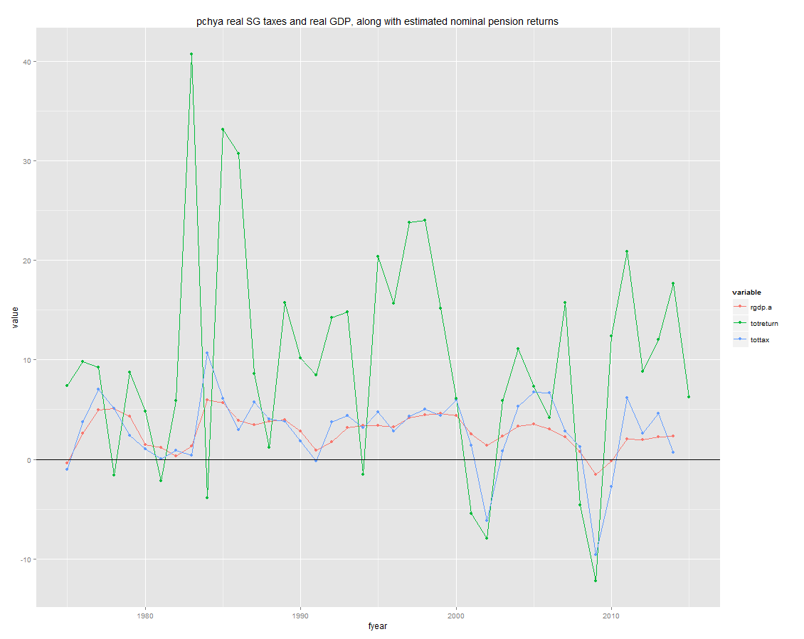

The lessons of the graph are:

* Real taxes are more volatile than real GDP, and have become more so in the last two recessions (reasons for this are well known).
* In the last 2 recessions (2001 and 2007) returns fell sharply as taxes fell sharply, and rose sharply as taxes rose sharply.
* While there may have been a relationship between returns and taxes before the last 2 recessions, it is not obvious from this graph. In principle, we know that declines in real GDP generally will drive taxes down, and we can see that in several prior recessions on the graph. They also probably – many people believe – drive real returns down, although that is not obvious, perhaps because I only have nominal returns here (inflation was higher and falling in the 1980s) or because of asset class mixes since bonds can deliver pretty strong returns when interest rates are falling. But in any event, it’s hard to know what to make of the period before 2000.

If the relationship between returns and tax bases were simple, we could model it. But it’s not, and we may never understand it well enough to model it. Obviously there are other variables and factors at work, and we’d need a lot more data.

But we can ask what would happen if we had a repeat of one or two historical episodes, where GDP, taxes, and returns were correlated. The goal is not to predict, but to understand a scenario, since something similar could happen again.

While I know Andrew Biggs didn’t like this when we discussed it on the phone, there we were talking about bootstrapping from history – drawing sequences of returns from history, as if history were a model for what the future will look like, when in fact many/most capital market observers believe that current expectations for nominal returns should be considerably lower. But I think when drawing a single scenario, it is different –we’re point to a period of stress in the past and asking what would happen if something similar happened again.

# Approach

The basic idea is to construct one or two episodes that are very much like what we observed in the past. For each episode, we would want a sequence of years, with the following information:

* Growth in real GDP
* Growth in real tax bases
* Nominal and real investment returns

The goal would be to run a single deterministic run, perhaps with a few years of smooth results, and then entering the stress and recovery periods, with returns similar to past stressful period, and taxes also similar. We’d then examine how required contributions change, and how large that is relative to the tax base.

We could simply use historical data for the last 2 recessions, but for a few complications:

* Taxes:
  + There are no data on tax “bases”. There are data on tax revenue, but those are a little suspect because they include tax policy changes (e.g., tax increases in response to recession). Thus, we might want to construct a cleaner tax base.
  + Different taxes behave differently in recessions, and states have different tax structures, so even if they all had the same economies they would have different results. We can’t create a scenario for each state, but we could have information on different major taxes, and combine them in prototypical ways. (Note: I focus here only on state govts. I ignore local governments, which means I ignore the property tax, which tends to be relatively stable. That is for another day.)
* Returns:
  + The PPD data only have returns back to 2001. We’d like to have at least a few years before that, and much longer would be nice.
  + Asset allocations have changed and thus even if future returns by asset class were the same as the past, we would not have the same portfolio returns if we use current allocations. Thus, we’d like to have data by asset class.

This expands our needed data for historical episodes so that it is more like each of the following, by year:

* Growth in real GDP
* Growth in real tax bases (inferred from economic data, to extent possible)
  + Income tax base
  + Sales tax base
  + Other taxes “base”

[These are the 3 main taxes for the typical state]

* Nominal and real investment returns, by:
  + Cash
  + Bonds
  + Equities
  + Maybe other

# Taxes

Here is what happened to percent change in real state gov taxes (Census/BEA) and real GDP (BEA); iit is individual income tax, gst is general sales tax.

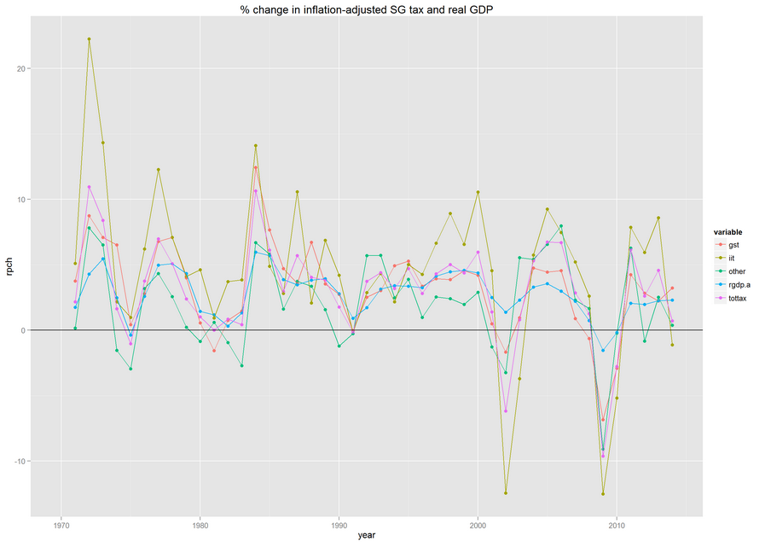

The lessons (as before) are:

* More volatile than GDP
* More volatile in last 2 recessions than prior
* Income tax much more volatile than sales, and much more volatile than before

The tax shares over the last several decades are shown below. The (volatile) income tax is a lot more important than it used to be.

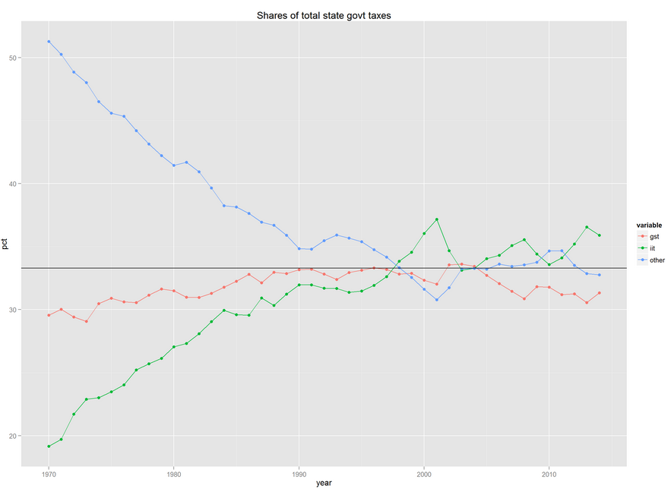

## Income tax base

The graph below gives some insight into why the income tax is so volatile. It shows several variables from IRS federal tax returns (state tax bases are quite similar to the federal base). These data are readily available from 1997 forward, with relatively little policy change; might be available for a few earlier years, but I think 1997 is probably early enough for our purpose. The variables are

* Agi adjusted gross income
* Netcgll net capital gains less losses – these are NOT included in traditional economic concepts such as personal income or, by extension gdp, and are a major reason state taxes are more volatile than the economy
* Nret number of returns
* Taxinc taxable income – what we would expect to be most closely aligned with state tax collections
* Wages wages on tax returns – very similar to the economic concept

These variables are all on a taxable year basis, which generally is the calendar year.

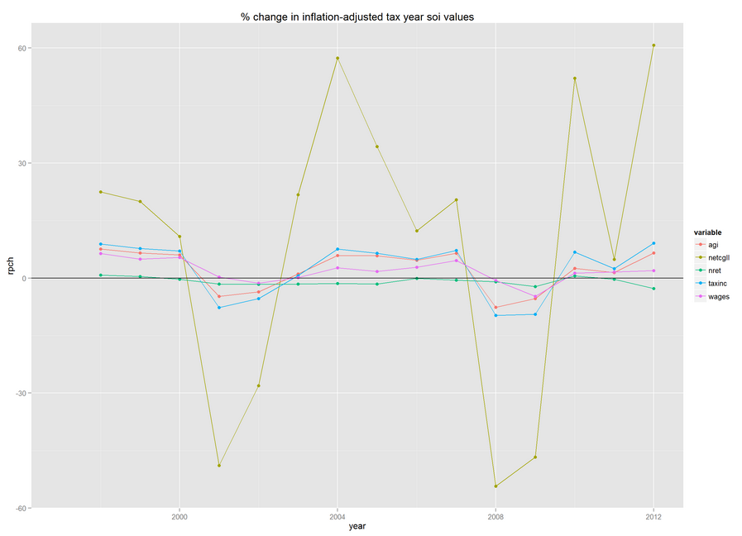

Obviously capital gains are a major driver of volatility. They are included in taxinc, which we would expect to be closely related to tax collections. (But for some timing issues and the progressivity adjustment issue we have discussed.)

Here’s the percent change in real income tax collections (iit), total tax collections (tottax), and agi and taxable income, with years shifted for agi and taxinc to correspond as closely as practical with the fiscal year in which taxes are collected.

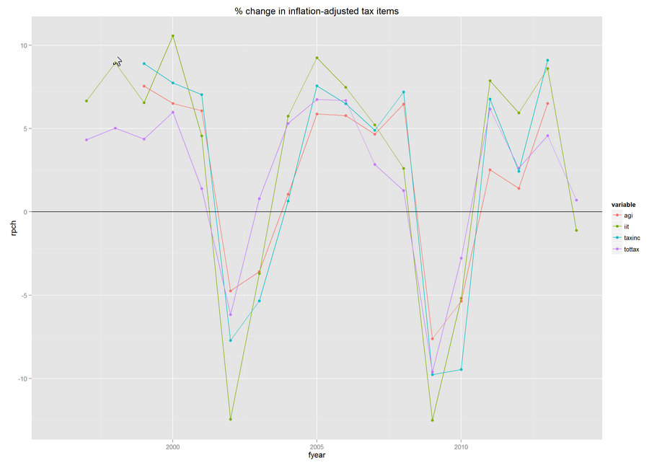

Taxinc seems reasonably well correlated with iit – the goal – as we would hope it is, and I propose that we use the percent change in real taxinc as our proxy for what happened to the income tax base in historical episodes. It is better than iit because tax collections would have been affected by tax policy changes over this period but relatively little happened to the income definitions over the period so taxinc is safer. I didn’t have time to work on a progressivity adjustment, but looking at the graph I’m not sure it’s crucial. Certainly there is a lot of volatility in taxinc without even taking into account the fact that changes in recessions make effective tax rates change pretty significantly. I’m thinking now that that could be a post-July enhancement.

## Sales tax base

As we discussed (and as 2nd figure shows), sales tax bases tend to be more volatile than the economy, in part because luxury items and other postponable purchases are heavily represented in the typical state tax base but necessities and other purchases that are harder to postpone are often partly excluded (e.g., food for consumption at home).

I constructed a synthetic typical sales tax base from details in NIPA Table 2.4.5. The items I included in the tax base are:

* All durable goods
* Nondurable goods: alcohol, clothing, gas and energy, and other nondurables excluding medical items and money spent abroad
* Services: electricity and gas, motor vehicles (e.g., repairs), recreation, restaurant meals and hotels, telecommunication services, and household maintenance

State sales taxes vary a lot but I think this is fairly typical, based on past reviews of sales tax summaries prepared by the Federation of Tax Administrators.

The figure below shows that this base has been declining substantially as a share of total personal consumption. This is consistent with the work of John Mikesell, U. Indiana, as we discussed.

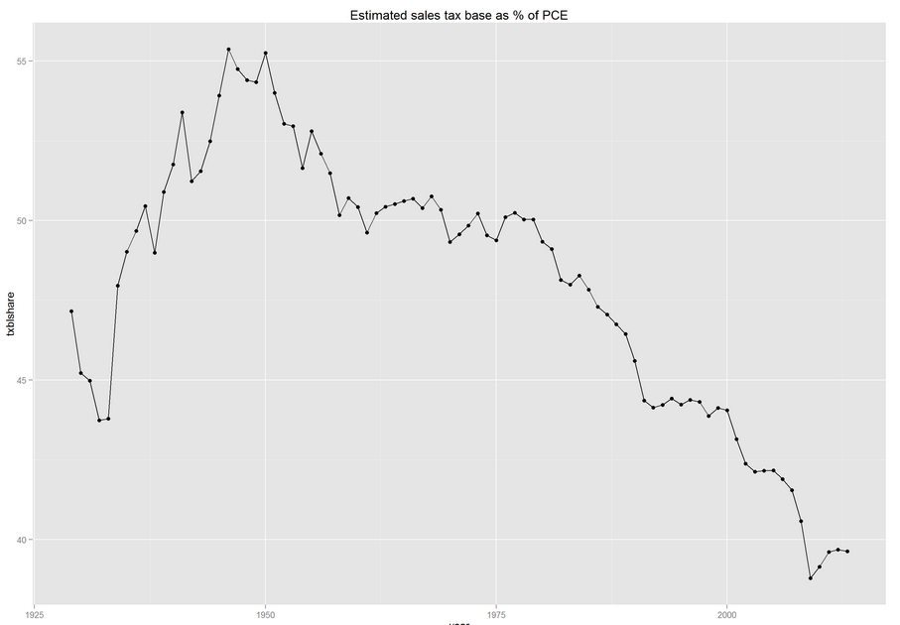

This next graph shows growth in general sales tax (gst) collections, real gdp, personal consumption (pce), and my constructed sales tax base, all adjusted for inflation with real gdp price index (not consumption indexes). I haven’t done goodness of fit measures, but to my eye the sales tax base does a very slightly better job of mimicking the sales tax than does pce or rgdp, although there are some big collections changes that it does not follow. (I suspect it could be related to seasonal adjustment even though these are annual data, but I haven’t had a chance to look.) For now I propose that we use this as our proxy for the sales tax base, but I do have to go back to my records to see what Mikesell has shared with me in the past; it could be useful.

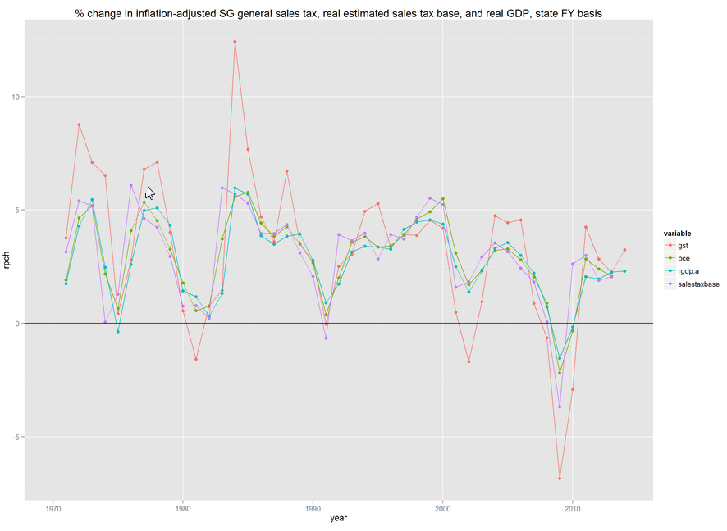

## Other taxes “base”

Other taxes are a potpourri of items that vary from state to state, including motor fuel taxes, cigarette taxes, corporate income taxes, and estate taxes.

Here’s percent change in real other taxes and real GDP. There’s obviously a relationship, albeit it is somewhat more volatile than gdp, plus there must be a lot of other things going on (including policy changes). There is no way we can construct a “base” for this given the different things that are included.

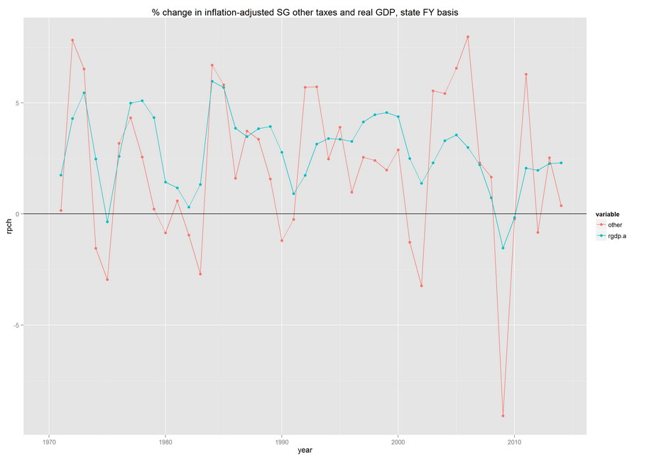

If we fit the percent change in other to percent change in GDP we get a more volatile series:

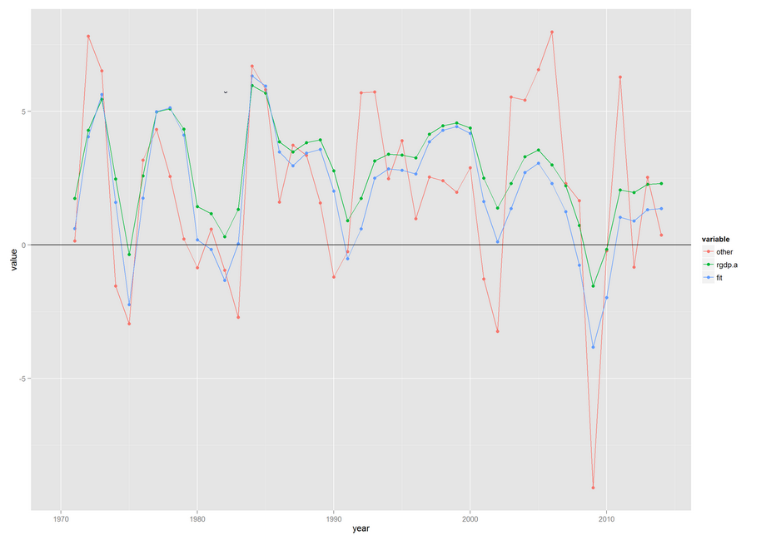

I propose we use either the percent change of the fit version or of real gdp to define how our “other” tax base moves.

## Taxes summary

Once we have percent change in a real “base” for each tax we can combine them in different proportions to show impacts on heavily income tax-dependent states or other states.

# Investment returns

As noted, the PPD returns only begin in 2001. Here’s the distribution:

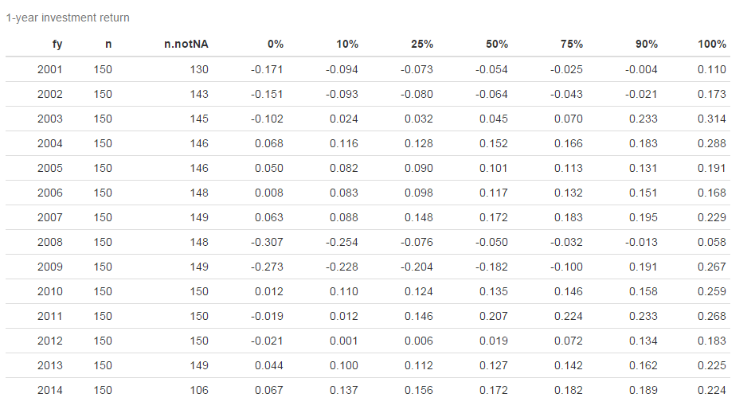

A few notes:

* Median drops of 5.4% and 6.4% in 2001 and 2002
* Median drops of 5% and 18.2% in 2008 and 2009; I thought it was worse than this; but I also looked at means weighted by asset size and the results weren’t much different
* While there are some big differences between p10 and p90, I think a lot of them would be related to different pension fund fiscal years – a fund operating on a calendar year could have very different investment return patterns from a fund operating on a June 30 fiscal year (as most do) even if it has the same asset allocation.

It would be nice to have a longer time series of investment returns, although I do think we could use investment returns for this period if we had to. We might then assume the years prior to 2001 had returns equal to the investment return assumption. I did look for actual returns data for public pension funds for prior years but have not found it; have not done an exhaustive search.

I explored several different approaches of constructing synthetic public pension fund returns, several of which could be workable, but I ended up with the following:

* Defined 4 asset classes
  + Cash
  + Bonds
  + Equity
  + All other
* Estimated public pension asset allocations over history using FRB Z1 Flow of Funds data on DB public retirement funds. I used the calendar year-end values, which was convenient – they are Dec 31 values, which is in the middle of the typical state fiscal year, which seems reasonable. Basically, I defined:
  + Cash as checking + savings + money market funds
  + Equity as corporate equity, plus an allocated share of mutual funds, based on the corp equity share of mutual funds economywide (there are not data specific to public pensions)
  + Bonds as credit market instruments plus an allocated share of mutual funds (same approach as for equity); incidentally this includes corporate bonds as well as government and agency bonds
  + All other as other (undesignated) assets plus direct investment in real estate (not treated as a financial asset in the FOF)
* Estimated asset class returns over history for these 4 classes in the same way as Aswath Damodoran of NYU Stern (<http://www.stern.nyu.edu/~adamodar>). I would have used his numbers, but he has calendar year data and I wanted data for the year ending on June 30. Thus, I proceeded as follows:
  + Cash: 3-month TBill, 12-month average, for period ending June 30. Data from FRED (TB3MS)
  + Bonds: 10-year constant maturity TBond from FRED (DGS10), daily, last day of 12 months ending June 30, calculated total return = promised coupon at beginning of year plus price change implied by change in yield. I don’t hit Damodoran’s numbers exactly when I do this on calendar year basis so I want to look some more, but I get quite close. So for now I am using it, for 12 months ended June. Note, though, that this is Treasuries only, and thus generally will have yields a little too low in comparison to what pension funds invest in, and prices changes could differ as well.
  + Equity: same basic approach as Damodoran – total return = (change in S&P500 close adjusted for dividends and splits, plus dividends) as % of prior year adjusted close. Data:
    - Dividends – I calculated monthly dividends using monthly dividend yield from Quandl (MULTPL/SP500_DIV_YIELD_MONTH) and month-end adjusted close prices from Yahoo finance via quandl (YAHOO/INDEX_GSPC), and then added dividends over 12 months ending in June to get annual
    - Adjusted close – as noted above
  + Other – I assume it is the average of bonds + equity return

Here are the DB public pension fund asset allocations I estimated from the FOF. Obviously equities and bonds tell 90% of the story:

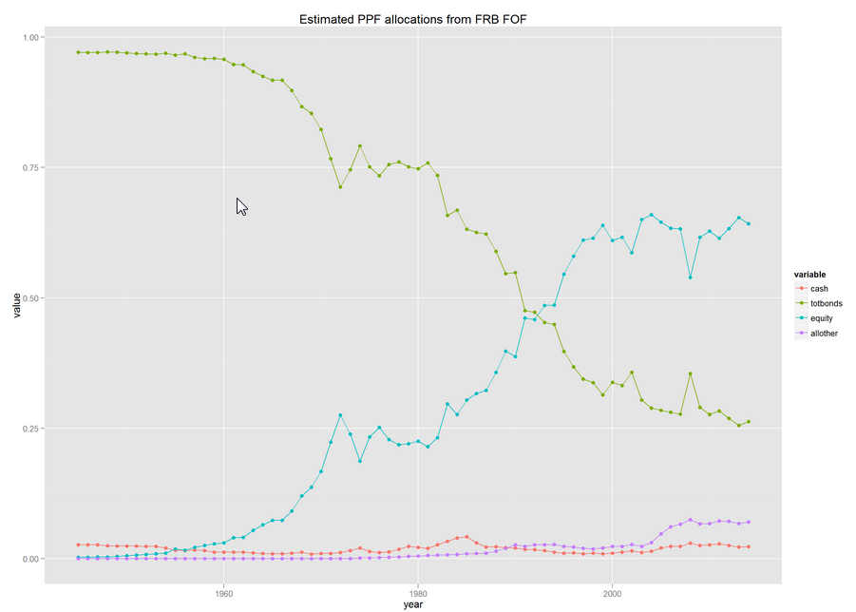

Here is the estimated annual public pension fund synthetic total return

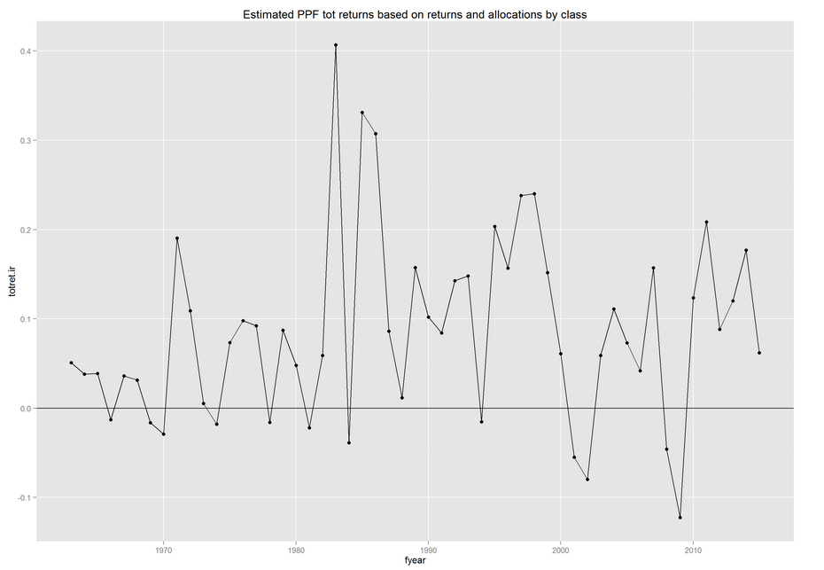

And here is the synthetic return (totret.ir) compared to median returns reported in the PPD (ppf.ir) and mean returns weighted by plan size (market assets) in the PPD (ppfw.ir). Despite some obvious weakness in the measure, it seems to me like a pretty good proxy for plan returns, allowing us to go back before 2001 if we need it (although the estimated 40+% return in 1983 certainly needs some investigation). One option would be to use median PPD returns for 2001+, and synthetic returns for earlier periods if we need them.

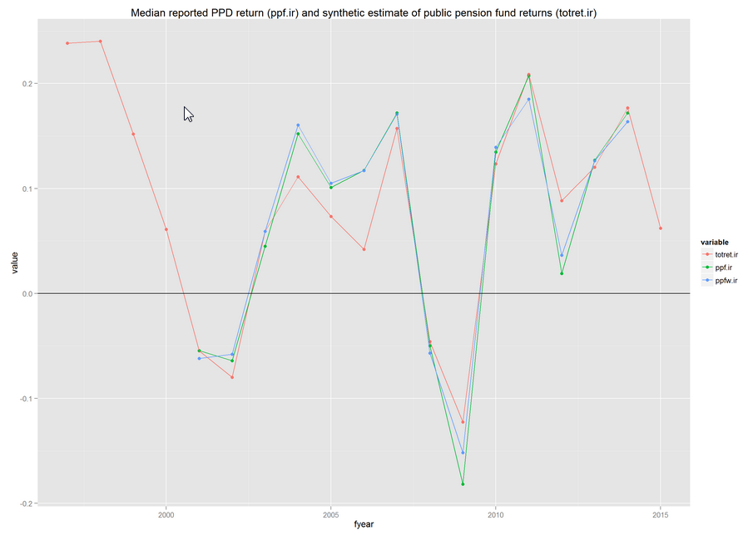

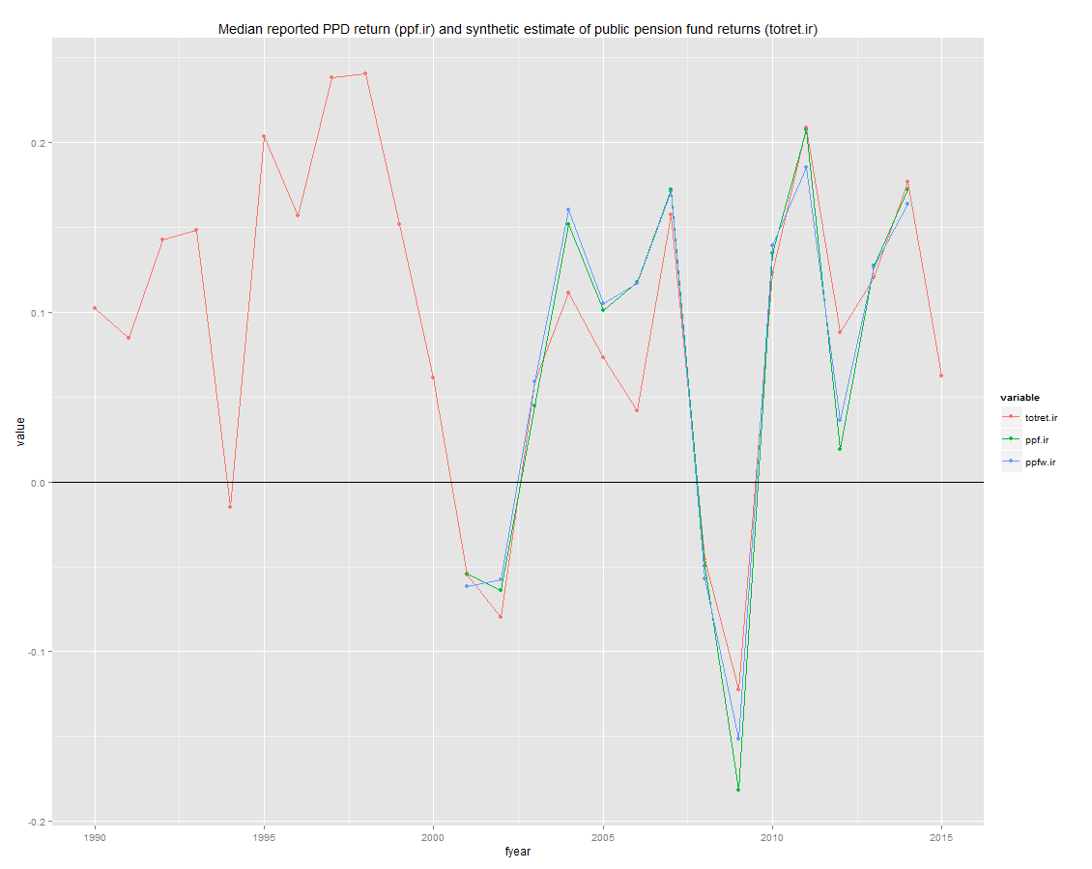

# To summarize

I propose we construct the following proxies for variables we care about, annually from 1997 through 2013, which gives us 16 years and either one long episode or two short episodes:

* Taxes
  + Income tax: % change in real taxable income from IRS, possibly forecast ahead a year or two (we could use CBO forecast)
  + Sales tax: % change in real sales tax base constructed from NIPA consumption components
  + Other taxes % change in real other taxes fit to real GDP (or possibly just use real gdp pch)
* Investment returns – I suggest using median PPD returns for 2001 forward, and synthetic returns for 1997-2000.

While I have not put all of these numbers in a single file, it is an easy matter.